1

The EU has also undertaken to work for a global agreement but, as Mr Lannoye pointed out, the Commission wishes to concentrate more on global partnerships, which is far from adequate. The EU will not, however, be deciding upon its contribution to Johannesburg until as late as the July summit. It is unfortunate that only a few EU Heads of State have undertaken to participate in the world summit for, without such high level participation, there are fewer possibilities of success. We have had enough words. What we need now is action. Mr President, of course it is depressing that

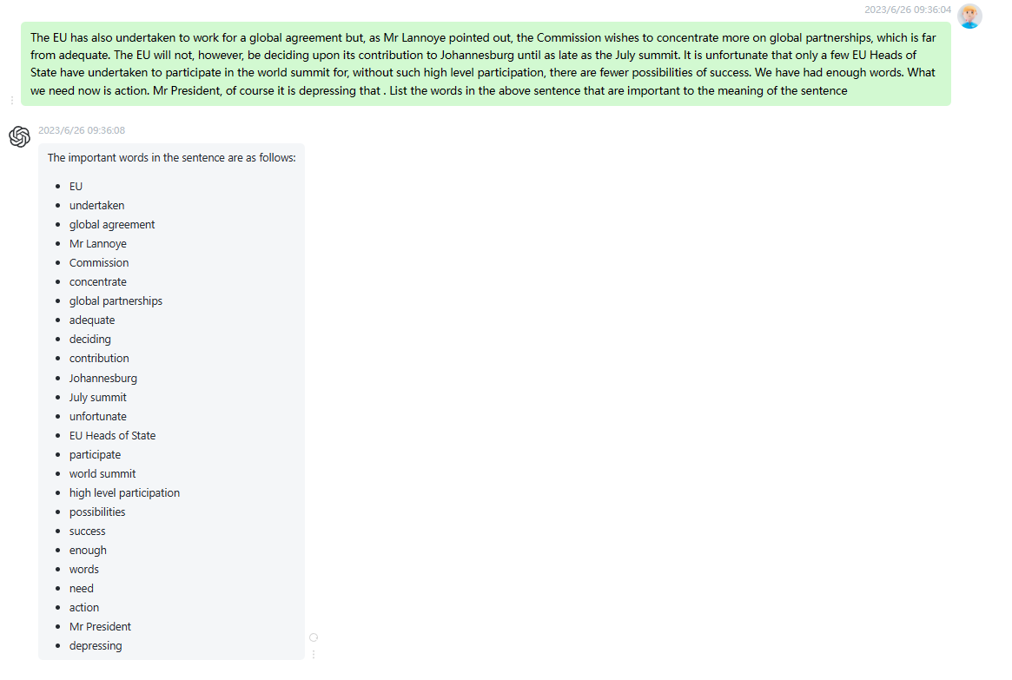

时延0.2s

2

Mr President, of course it is depressing that so little has been achieved since the Earth Summit in Rio. This excellent report confirms that. I would like to highlight one aspect in particular. I think Johannesburg must start here. I think that in this House, we sometimes fail to recognize the opportunities afforded to us in this context by the Treaty of Amsterdam, namely the co-decision procedure. We must wield this instrument with far more determination and vigour. Indeed, in my view, the greater our resolution in influencing the passage of European legislation on environmental matters, the greater our credibility

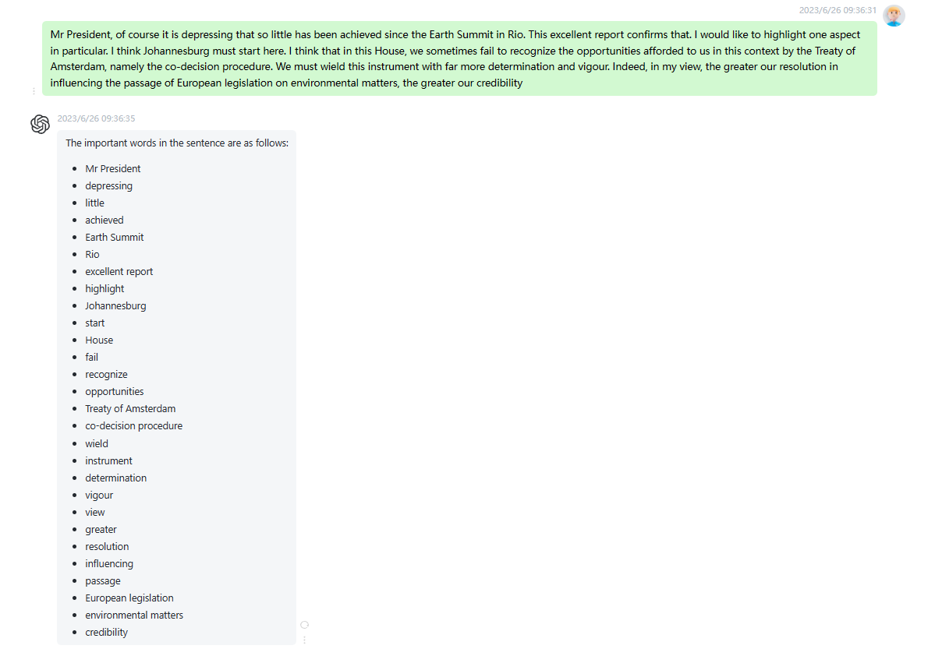

时延0.2s

3

Mr President, time is running out for the earth. In spite of a whole range of summits and conferences, few people can dispute that we are today a long way from achieving the objective of sustainable development. We are now in actual fact still further from that objective than when the Brundtland report was presented in 1987 and when the Rio Conference took place. The opposite ought, of course, to be the case. The other day, the OECD, which is not, of course, an environmental organisation, pronounced that All major global ecological indicators are negative. Things are just as bad

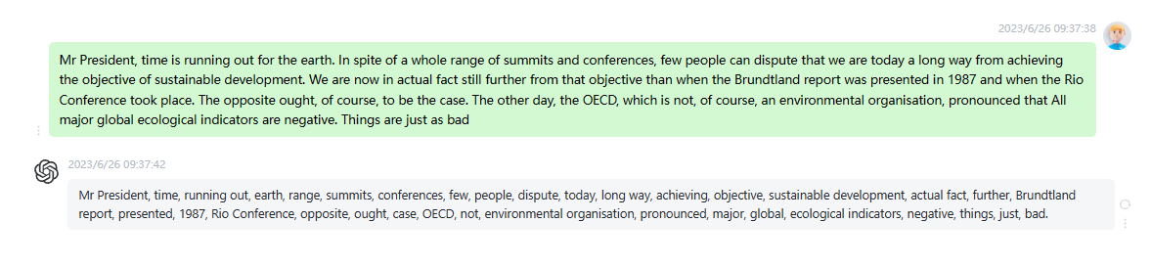时延0.2s

4

What are the reasons why we are still such a long way from achieving a sensible balance between economic growth, social development and consideration for the environment? There are two main reasons. First of all, there is strong resistance to implementing all the measures which, in a whole range of conferences, government says it recommends: for example, doing away with subsidies to industries which are harmful to the environment; incorporating environmental costs into prices; establishing clear environmental criteria for our export credits guarantee boards so that we do not export non-sustainable systems to the developing countries; and, in general, encouraging,

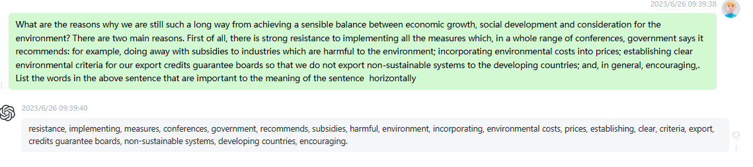

时延0.1s

5

Secondly, development is proceeding slowly because, as I see it, we have models for both education and economics that are unduly top down and reductionist. We have chosen to organize our society by focusing on specialization. There are more than 20000 different disciplines in our universities, and specialization is, of course, good for solving a variety of individual problems. There are, however, extremely few experts engaged in the solution of cross-border problems. The Johannesburg Summit is now to try to solve all these problems.

Alongside the short term measures, we must, then, also reflect upon the big picture and ensure

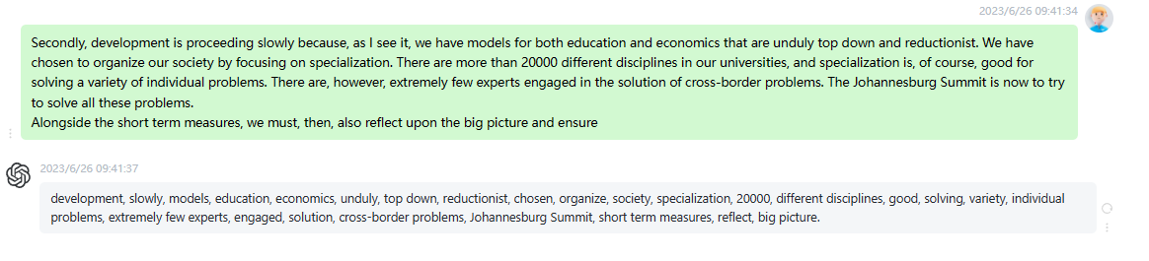

时延0.15s

6

We cannot talk about a global partnership for sustainable development without highlighting the link between poverty and environmental destruction. Poverty breeds population growth. It is estimated that by 2015, the global population will have reached 7.5 billion. This means more pressure on natural resources and more pressure on the environment. In this context, I would like to stress the importance of greater efforts to ensure women legal equality and their right to protection of their reproductive health, and to strive for progress in these areas. I should also like to touch specifically on the proposed amendments. My group will not

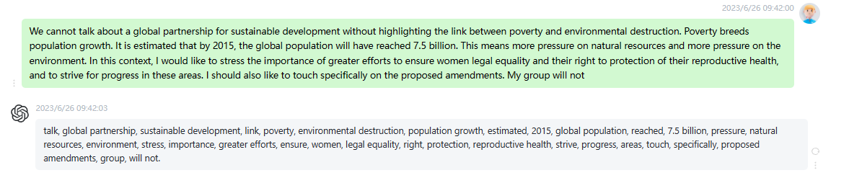

7

So many opportunities were presented in Rio, and as Mr Papayannakis report states, so many expectations were raised with the Kyoto Protocol, the Cartagena Protocol and so on, but they failed to progress. It is not really any surprise that so many NGOs are already predicting negative outcomes for Johannesburg. But people expect us in the European Union to take a lead on these issues and we cannot shirk that responsibility. In another ten years, people will be asking what action we took in 2002 to address and to reverse the lack of progress in the past ten years. Other

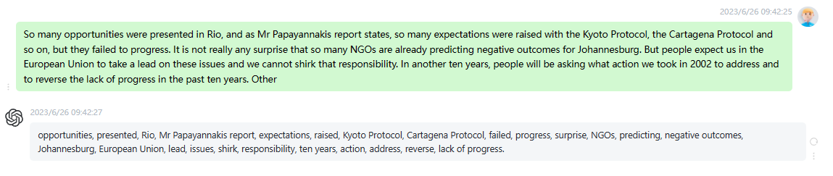

时延0.1s

8

The future needs sustainable communities in the true definition of that concept. Today, about half of the 6000 or so languages spoken in different parts of the world are under threat: that means that 3000 languages are either seriously endangered or are dying. The need to protect and enhance the diversity of cultures in the world becomes even more urgent in the face of increasing globalization. We need to ensure that an artificial polarization between the needs of the environment and the needs of people is not allowed to develop any further. I welcome the positive and the constructive comments

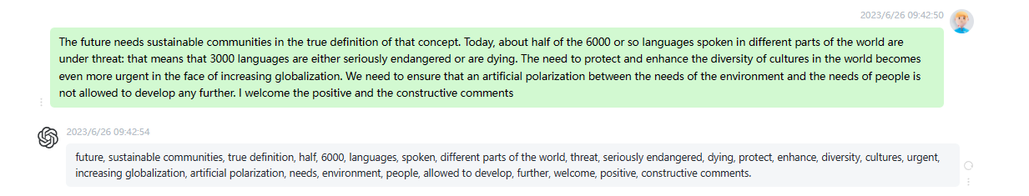

时延0.2s

9

We should like to be optimistic, even though there are plenty of reasons to hold a different or even opposing view: the enormous delays in complying with the gains made at Rio, the North south divide, the perpetuation of poverty and the debt itself, the insistence on unsuitable and unfair economic recipes, the lack of political will on the part of the rich countries - especially the United States to alter guidelines that they themselves determine and to make available the resources needed for worldwide change, which, after all, would benefit(1) everybody(1). Even recently, Monterrey, despite its last-minute decisions, was

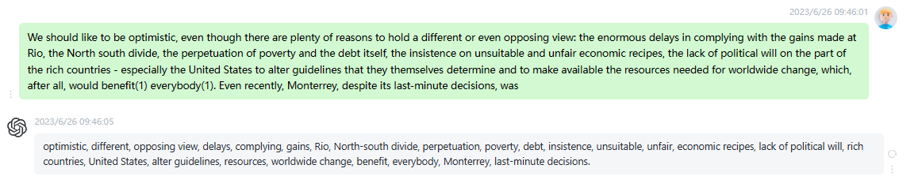

时延0.2s

10

It is high time we did something about this. If the EU wishes to continue to play its pioneering role, it is of major importance for it to find resonance with the people. And at the moment, people are particularly concerned with issues such as security and health. It therefore goes without saying that we should take advantage of this. Indeed, if we continue to neglect the environment, this will irrevocably lead to yet more floods, forest fires, pollution and poor health for a large number of people. In short, without sustainable development, not only the environment will be damaged,

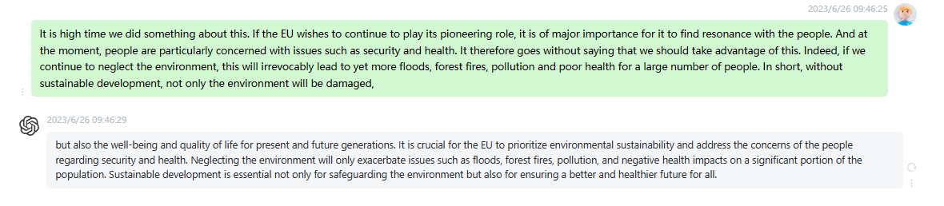

时延0.2s